

A booklet of tips for Neurodivergent teachers.

By Lynn McCann

Autism, ADHD, PDA Specialist Teacher

ADHD Diagnosed.

1. Supportive Advice for Neurodivergent Trainee Teachers



1. Know Your Rights
- The Equality Act 2010 protects you if your needs have a “substantial and long-term” effect on daily life.
- You have the right to reasonable adjustments in training, placement and interviews.
- You do not have to disclose your diagnosis unless you want support or adjustments.
- You cannot be legally treated worse because of your neurodivergence.
You are allowed support. You are allowed adjustments. The law says you must not be discriminated against. You choose when and if you tell people.

2. Know There Are Risks to Disclosure
- Some schools are very understanding. Others are not.
- Disclosing too early may lead to assumptions about what you can or cannot do.
- Disclosing too late may delay support you need.
- You get to decide when, how much, and to whom you tell.
- Disclosure is safest where leadership is known to be inclusive.
You can choose when to tell. Some places react well. Some don’t. Think carefully and protect yourself.

3. How to Decide When to Disclose
- Before placement: if you need adjustments to start safely (e.g., sensory needs, communication preferences, dyslexia tools).
- After you meet your mentor: if you want to build trust first.
- Not at all: if you feel unsafe or unsure — this is your right.
Tell early if you need support straight away.
Tell later if you want to get to know them first.
Don’t tell at all if it feels unsafe.

4. How to Check if a School Is Psychologically Safe (Before or During Interview)
Ask yourself these simple questions:

Environment clues
- Do staff seem calm, friendly and respectful to each other?
- Is the school tidy and organised, or chaotic and overwhelming?
- Are there quiet spaces for staff to work?

Leadership clues
- Do leaders talk about inclusion in a genuine way, not just in posters?
- Do they show interest in staff wellbeing, workload and boundaries?
- Do they mention reasonable adjustments without being prompted?

Interview clues
- Do they give clear questions, not vague or fast ones?
- Do they offer extra processing time or written questions?
- Do they explain the day’s structure and expectations clearly?

Culture clues
- Do they speak kindly about pupils with SEND?
- Do they value different ways of thinking, or do they expect everyone to “fit the same mould”?
- Does the school website show inclusive values in action (not just words)?
Safe schools show respect, clarity, kindness and flexibility.
Unsafe schools are rushed, vague, judgmental or dismissive of difference.

5. Signs a School May Be Safe to Disclose To
- They ask, “Is there anything that would help you do your best here?”
- They talk about reasonable adjustments openly.
- They listen without judgement.
- They give you time to think before answering.
- They speak positively about diversity in staff and pupils.
If they make you feel listened to, respected and calm, it may be safe.

6. Signs You Might Want to Delay or Avoid Disclosure
- They rush you, interrupt you, or seem irritated when you ask for clarity.
- They talk about staff needing to be “tough” or “resilient” instead of supported.
- They blame pupils for behaviour instead of understanding needs.
- They laugh about “snowflakes”, “excuses”, “special treatment”, etc.
- You leave feeling uncomfortable, confused or drained.
If they make you feel judged or unsafe, keep your information private.

7. Practical Tips for Trainees
- Ask for interview questions to be given in writing if needed.
- Use checklists, timers, visual schedules and written routines to support EF needs.
- Ask mentors to give clear, step-by-step feedback instead of lots at once.
- Use quiet spaces for planning where possible.
- Ask for dyslexia tools (coloured overlays, text-to-speech, extended deadlines).
- Keep a record of what works for you — this helps with future adjustments.
Small supports can help you shine. Ask for what helps.

8. Final Message
You deserve to train in a school that respects you, understands your needs, and celebrates your strengths. Your neurodivergence is part of who you are — not a problem to hide. The key is choosing safe, supportive environments that allow you to thrive.

Part 2

Making Teaching More Manageable: Tips for Neurodivergent Teachers

2. Making Teaching More Manageable: Tips for Neurodivergent Teachers
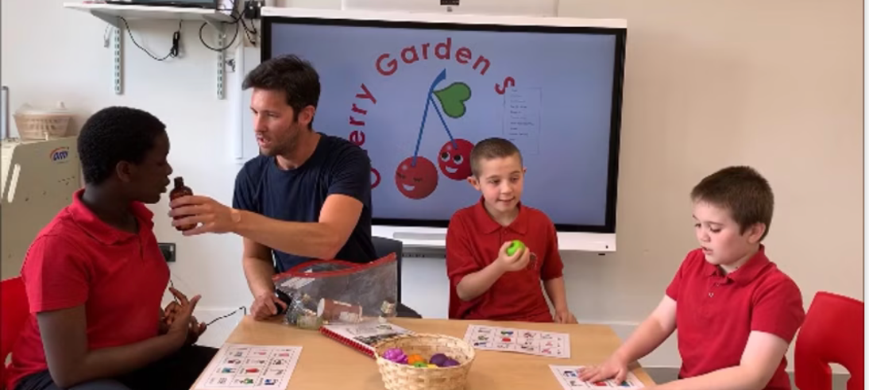

1. Set Clear Communication Expectations Early
- Tell colleagues how you work best (e.g., “I understand instructions better when they’re written down”).
- Ask for written follow-ups after meetings or verbal instructions.
- Let people know if you need extra time to process questions.
- Ask mentors to give step-by-step, not rushed or overloaded, feedback.
- Share your preferred communication method: email, bullet points, short check-ins, or messages at agreed times.
Tell people how to communicate with you in a way that helps you succeed.

2. Manage Paperwork and Deadlines in Clear, Visual Ways
- Use a visual calendar (digital or paper) to track dates and data drops.
- Colour-code tasks by urgency (red = now, yellow = soon, green = later).
- Break big tasks into small steps and tick them off one at a time.
- Keep all essential documents in one place — a folder, app, or shared drive.
- Use AI or digital tools to summarise long documents, draft emails, or create templates so you’re not starting from scratch.
Use colour, visuals and small steps to stay on top of paperwork.

3. Use a Simple Prioritising System (Kanban)
A Kanban board helps you see what needs attention. You can use a whiteboard, sticky notes, or a digital tool (Trello, Notion).
Create three columns:
- To Do
- Doing
- Done
Move tasks between columns to stay clear and reduce overwhelm.
Keep no more than 3 tasks in the “Doing” column — this prevents overload.
See your tasks clearly. Only do a few at a time. Move them when you finish.

4. Plan for Sensory Needs Before Problems Happen
- Choose quieter spaces for PPA (planning time) if possible.
- Wear earplugs or noise-reducing headphones when marking or planning.
- Use sensory tools like fidgets, weighted items, movement breaks or chewing gum (if allowed).
- Ask for a desk location that reduces visual and sound distractions.
- Adjust lighting, seating and equipment in ways that keep you regulated.
Use tools and spaces that keep your body and senses calm.

5. Reduce Social Overload in Safe, Respectful Ways
- Set a boundary like: “I need quiet time at lunch to reset — happy to chat another time.”
- Take short breaks alone when needed.
- Keep conversations to a time limit if they drain you.
- Build relationships at your pace — start with one or two safe colleagues.
- Let people know you may need time to think before responding.
Protect your energy. You choose when and how to socialise.

6. Have Pre-emptive Discussions With Colleagues
- Talk with your mentor about what helps you stay organised and regulated.
- Let colleagues know early if you need:
  - written expectations
  - slower-paced instructions
  - reminders for key deadlines
  - reduced interruptions while working
- Explain your strengths too (e.g., creativity, deep knowledge, problem-solving, empathy).
Explain what helps you, and what you are great at. This builds trust.

7. Make Adaptations That Reduce Executive Function Load
- Use templates for lesson plans, emails and reports.
- Use checklists for repeated routines.
- Prepare resources the day before to reduce morning stress.
- Keep your classroom tidy and labelled so you can find things quickly.
- Use “body doubling” — planning or marking alongside a trusted colleague — to help with task initiation.
Make repeated tasks simple and automatic.

8. Create Healthy Boundaries Early
- Decide your non-negotiables (e.g., leaving by 5pm three days a week).
- Limit how many extra duties or clubs you take on.
- Say, “I need to think about that and get back to you,” instead of saying yes quickly.
- Protect rest time so you don’t burn out in your first term.

Easy-read summary:
Set limits to protect your energy and wellbeing.

9. Use Technology and AI as Your Support Team
- Ask AI to summarise policies, checklists or long emails.
- Use dictation tools if writing is tiring.
- Use text-to-speech for reading long documents aloud.
- Use calendar apps with reminders that pop up automatically.

Easy-read summary:
Let technology do the boring or heavy tasks.

10. Final Encouragement
You bring unique strengths, insights and creativity to teaching.
By planning early, setting boundaries and asking for the communication and sensory support you need, you can make teaching far more manageable and enjoyable. You deserve environments that help you thrive — not just survive.

Part 3

Teaching Pupils With SEND: Strength-Based Tips for Neurodivergent Teachers

3. Teaching Pupils With SEND: Strength-Based Tips for Neurodivergent Teachers
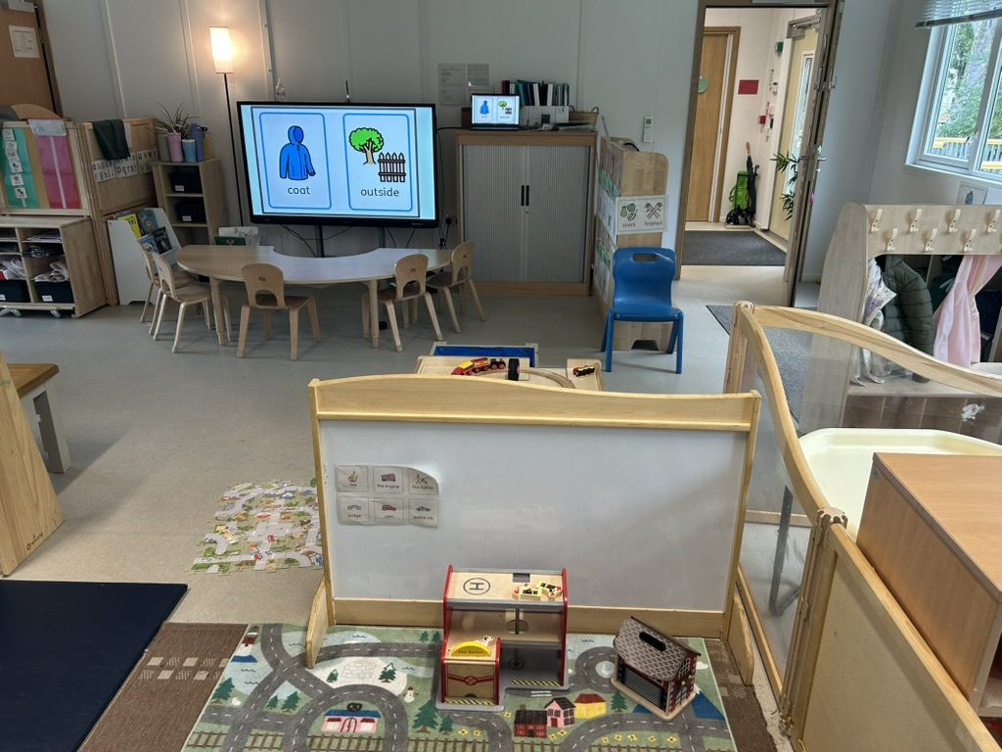

1. Use Your Strengths and Lived Experience
- You already understand what it feels like to struggle, mask, or need clarity.
- This makes you naturally empathetic and patient with pupils.
- Your problem-solving skills and creativity help you adapt quickly.
- Your detail-focused or big-picture thinking can help identify what a child truly needs.
Your experiences help you understand pupils in ways many others can’t.

2. Build on Each Child’s Strengths First
- Look for what the child can do, not just what they find hard.
- Notice their interests, skills and passions.
- Use strengths to teach new skills (e.g., Pokémon, Minecraft, drawing, movement).
- Celebrate small steps and progress.
Start from what they enjoy and what they’re good at.

3. Use Universal Approaches From the Start
These support all learners and reduce stress for you too:
- Clear, simple, step-by-step instructions.
- Visuals, schedules, timers and routines.
- Predictable classroom rules written positively.
- Chunking tasks into smaller parts.
- Sensory-aware teaching (e.g., quiet corners, reduced clutter, calm tone).
- Allowing pupils alternative ways to show learning (drawing, typing, speaking, using objects).
Good SEND strategies help every child — and make your life easier too.

4. Listen to the Child’s Voice
- Ask the pupil what helps and what doesn’t.
- Use drawing, symbols, thumbs-up/down, or simple questions if they struggle with words.
- Check in regularly: “Is this working for you today?”
- Respect their communication style (quiet, non-verbal, movement-based, direct, etc.).
The child is the expert in themselves. Listen to them.

5. Build Warm, Respectful Relationships With Parents
- Greet them kindly and show interest in their child’s strengths.
- Ask: “What works well at home?” or “What helps when things feel hard?”
- Keep communication simple — short notes, bullet points, or quick positive updates.
- Avoid blaming language; focus on partnership and problem-solving.
Parents know their child best. Work together, not alone.

6. Work Closely With Teaching Assistants and Professionals
- TAs often know the child’s signals, routines and sensory needs.
- Ask therapists, SENCOs and support staff for practical tips you can use tomorrow.
- Be open about what you find confusing — you are allowed to learn.
- Share what is working in your classroom so everyone stays consistent.
You are part of a wider team. Use their knowledge.

7. Trust Your Instincts
- If something feels wrong, overwhelming, or not fair to the child — pause and reflect.
- Neurodivergent teachers often notice subtle signs others miss.
- Speak up softly but firmly if a child is distressed, struggling or misunderstood.
- You are allowed to try ideas that make sense to you, even if they are different.
Your instincts are usually right. Trust your insight.

8. Create a Safe, Calm Environment
- Keep your classroom organised so pupils (and you) know what to expect.
- Use movement breaks, sensory tools and quiet areas.
- Keep transitions smooth and predictable.
- Avoid sudden changes unless absolutely necessary.
Calm spaces help everyone learn.

9. Celebrate Diversity in Thinking and Learning
- Explain to pupils that everyone learns differently — and that is okay.
- Model acceptance by talking positively about different brains and strengths.
- Share your own strategies (e.g., “I use a checklist too; it helps me stay organised”).
Show pupils that different ways of thinking are valued.

10. Final Encouragement
Your neurodivergence is not a barrier — it is a powerful asset.
You bring empathy, creativity and lived understanding of difference.
When you use universal strategies, listen deeply, and trust your instincts, you create a classroom where all children — especially those with SEND — can feel understood, safe and capable.

Acknowledgements:
Hilary Forbes – ND teacher and Maths Tutor
Catrina Lowry - https://neuroteachers.com
Amy Cooper (ISTIP) - https://www.linkedin.com/in/amy-cooper-fcct-frsa/?originalSubdomain=uk

