Sensory activities can help me feel ready for learning.
My name is ___________________. 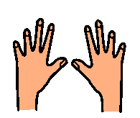
At school we have times when we need to listen to the teachers, do some work and stay still for a while.
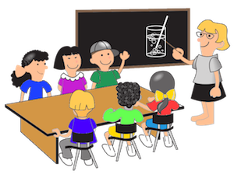
When people need to pay attention, they might want to fiddle with things, move or stim. This is what the body does to help the brain get ready to learn.
These are the things that might help me concentrate.
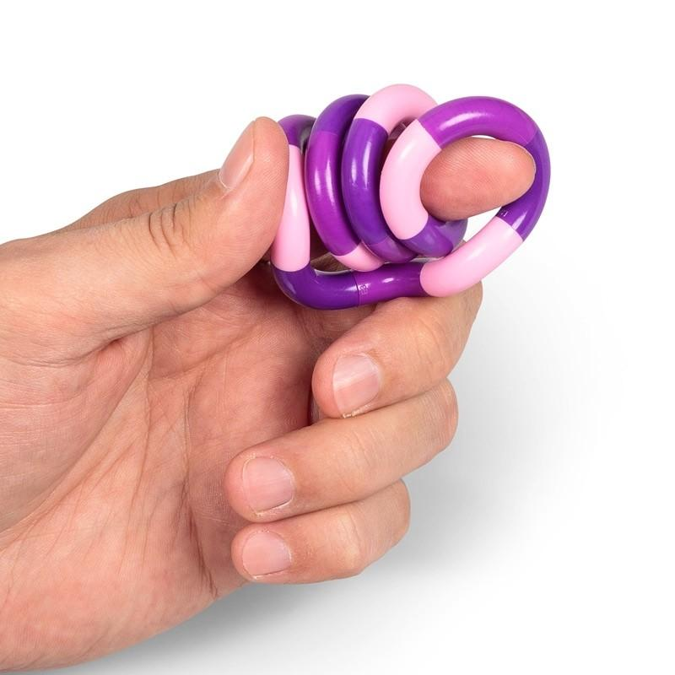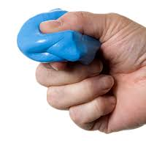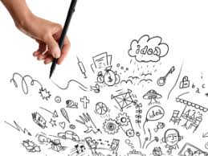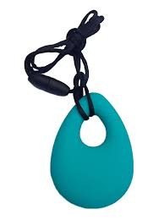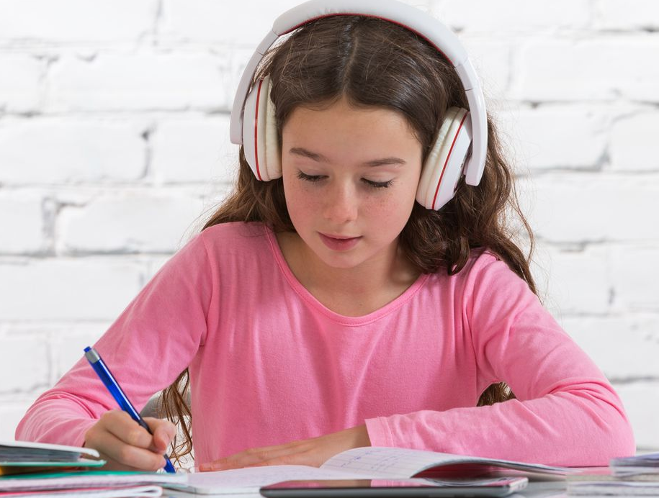

If fiddling with things can help me keep focussed on the lesson, then I can use them. This is great. I can try to keep it calm and quiet enough so that the children around me are not distracted. They might have their own way of keeping their attention in the lesson. This is okay too.
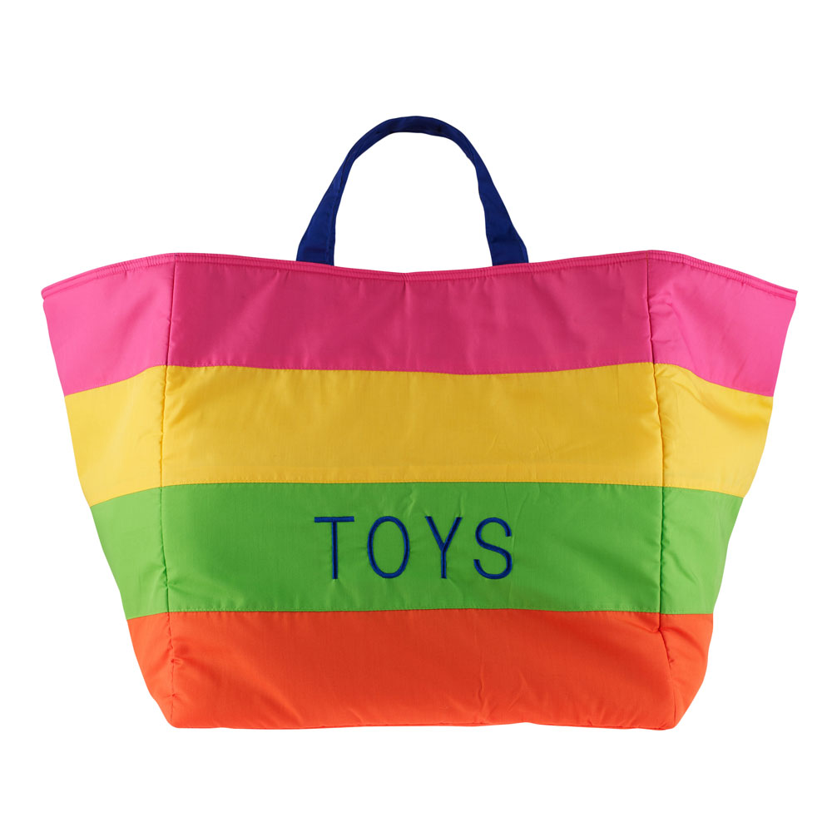
These are the activities that help me concentrate. If they are not doing their job, then I can put them back in the bag. I can use them another time. I might need to do something else like have a sensory break or go for a walk. This is okay too.

Sensory Activities can help me feel ready for learning. Brilliant me!

