Comfortable spaces

My name is _________ and I go to ___________ school.

There are lots of children in my class.
- Sometimes we sit near each on the carpet.
- Sometimes we sit near each other at the table.
- Sometimes we stand near each other in the line or when we are chatting.

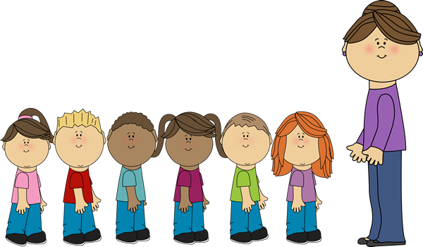

Sometimes we stand very close to people. This can be uncomfortable for some people. They might not like someone touching them or being so close they might bump together.

Sometimes people like standing or sitting close to others. They DO find it comfortable.

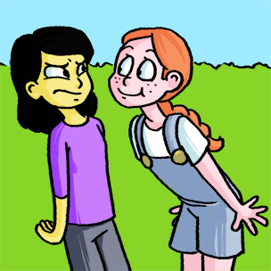
The trouble is that some people like being close and some do not.
So we try to have a good rule to make everyone comfortable.

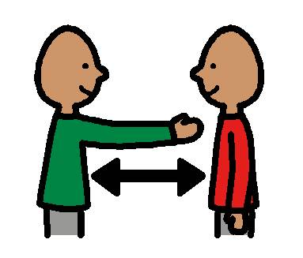

It is good when people have a bit of space between them. About the width of a person is a good idea.

If you are too close it is a good idea to take one step back. This is so that everyone has the chance to feel comfortable and enjoy being around other people.

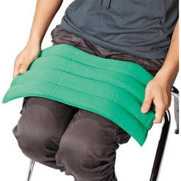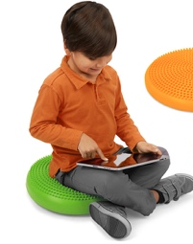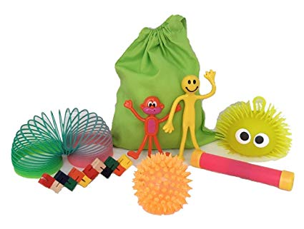

If I like to sit very close to people I could have a sensory cushion or toy that can help me feel comfortable in a similar way.

I can ask other people to take one step back too. It can help everyone.

This is brilliant.

